JS Apps Exam – Pet My Pet Single Page Application

Using libraries like jQuery, Handlebars and Sammy is allowed but is not obligatory. You are assigned to implement a Web application (SPA) using HTML5, JavaScript, AJAX, REST and JSON with cloud-based backend (Kinvey). The app keeps users and pets. Users can register, login, logout , view a dashboard with all pets sorted by likes (a helper function will be given). They will also be able to view the pets by category, add a new pet, edit/delete their own pets, show other pets details and a section where they can view their own pets.

Create a Kinvey REST Service
Register at Kinvey.com and create an application to keep your data in the cloud.
Create a collection pets. Each pet has a name, description, imageURL, category and an likes.
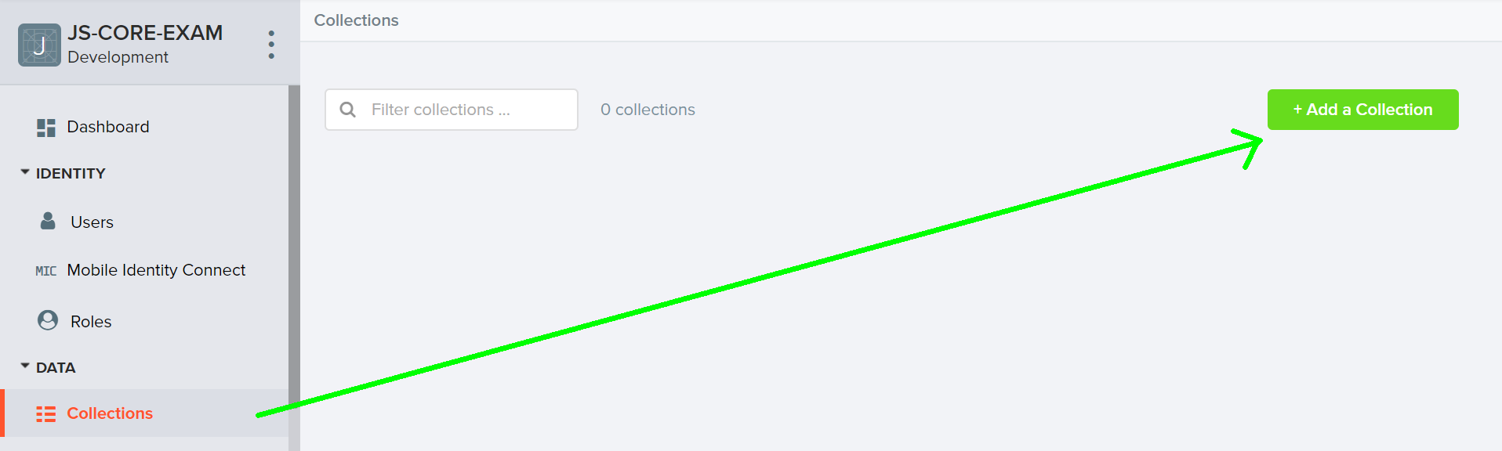
You are given one json file to import data for pets.
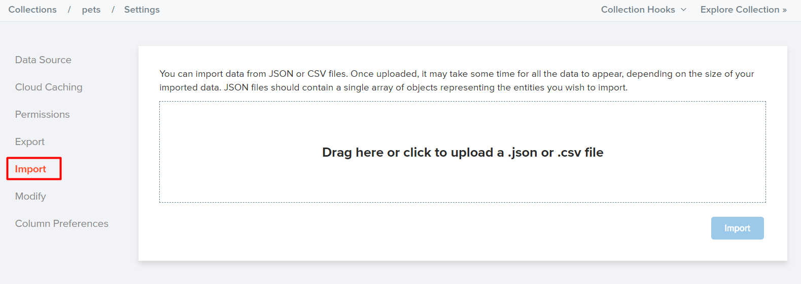

In order to be able to keep track of the likes of each pet, you need to allow all users to edit this collection. So go to the properties of the collection:
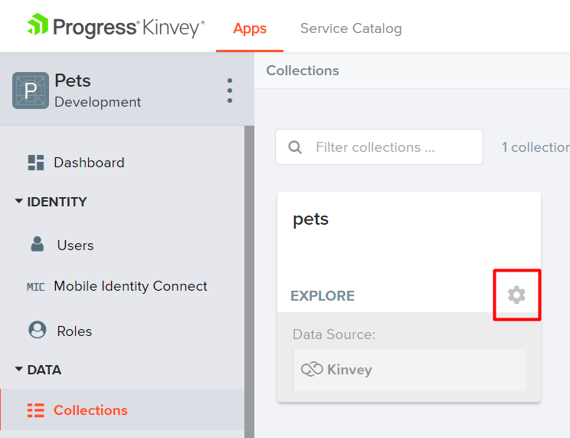
Then go to permissions and edit them to look like this:
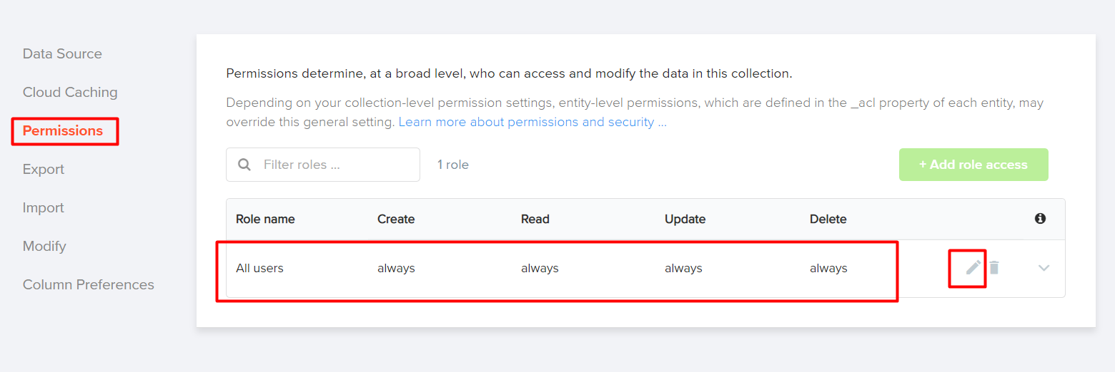

Test the Kinvey REST Services
Using Postman or other HTTP client tool (you can use Kinvey’s built-in API Console), test the REST service endpoints:

User Registration (Sign Up)
POST https://baas.kinvey.com/user/app_id/
Request headers | Authorization: Basic base64(app_id:app_secret)  Content-Type: application/json
Request body | {  "username": "testuser",  "password": "testuserpass890"  }
Response  201 Created | {  "_id": "59930c78a743e20c7d3fca77",  "username": "testuser",  "password": "testuserpass890"  }
Error response  409 Conflict | { "error": "UserAlreadyExists", "description": "This username is already taken. Please retry your request with a different username", "debug": "" }
Error response  401 Unauthorized | { "error": "InvalidCredentials", "description": "Invalid credentials. Please retry your request with correct credentials", "debug": "" }
The request needs "Basic" authentication. Use the Kinvey App Key and Kinvey App Secret as credentials.
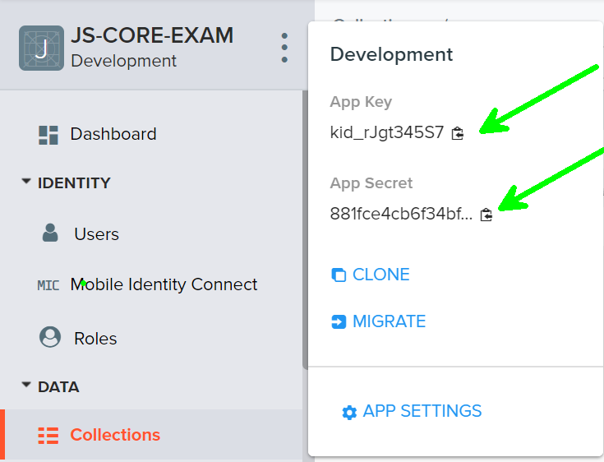

User Login
POST https://baas.kinvey.com/user/app_id/login
Request headers | Authorization: Basic base64(app_id:app_secret)  Content-Type: application/json
Request body | {  "username": "testuser",  "password": "testuserpass890"  }
Response  200 OK | {  "_id": "59930c78a743e20c7d3fca77",  "username": "testuser"  "_kmd": {  "authtoken": "8e6471bc-3712-4cfb-b92e-50e62a0c80….Duj5fHdM /7XHIe6KdY="  …  },  …  }
Error response  401 Unauthorized | { "error": "InvalidCredentials", "description": "Invalid credentials. Please retry your request with correct credentials", "debug": "" }
Successful login returns an "authtoken" which is later used to authenticate the CRUD operations.

User Logout
POST https://baas.kinvey.com/user/app_id/_logout
Request headers | Authorization: Kinvey authtoken
Response
204 No Content
Error response  401 Unauthorized | { "error": "InvalidCredentials", "description": "Invalid credentials. Please retry your request with correct credentials", "debug": "" }
To logout, you need to provide the "authtoken" given by login / register as "Kinvey" authorization header.

List all Pets (Dashboard – sorted by likes, descending)
GET https://baas.kinvey.com/appdata/app_id/pets?query={}&sort={"likes": -1}
Request headers | Authorization: Kinvey authtoken
Response  200 OK | [  {  "name": "Lilly",  "description":"This is my cat Lilly. She is 2 years old and is lazy",  "imageURL":"https://www.bluecross.org.uk/sites/....jpg",  "category":"Cat",  "likes":"7"  "_acl": {  "creator": "5bb08c01eb7615589b4f360e"  },  "_kmd": {  "lmt": "2018-10-03T08:04:26.028Z",  "ect": "2018-09-30T09:26:13.051Z"  }  },...  ]
Error response  401 Unauthorized | { "error": "InvalidCredentials", "description": "Invalid credentials. Please retry your request with correct credentials", "debug": "" }

Create Pet
POST https://baas.kinvey.com/appdata/app_id/pets
Request headers | Authorization: Kinvey authtoken  Content-Type: application/json
Request body | {  "name": "Pepi",  "description":"This is my 2 years old parrot named Pepi. He sings all the time.",  "imageURL":"http://pngimg.com/uploads/parrot/parrot_PNG723.png",  "category": "Parrot",  "likes": "0"  }
Response  201 Created | {  "_id": "59931398996ab5127d2a84d1",  "name": "Pepi",  "description":"This is my 2 years old parrot named Pepi. He sings all the time.",  "imageURL":"http://pngimg.com/uploads/parrot/parrot_PNG723.png",  "category": "Parrot",  "likes": "0"  }
Error response  401 Unauthorized | { "error": "InvalidCredentials", "description": "Invalid credentials. Please retry your request with correct credentials", "debug": "" }

Edit Pet
PUT https://baas.kinvey.com/appdata/app_id/pets/pet_id
Request headers | Authorization: Kinvey authtoken  Content-Type: application/json
Request body | {  "name": "Pepi",  "description":"This is my 2 years old parrot named Pepi. He sings all the time.",  "imageURL":"http://pngimg.com/uploads/parrot/parrot_PNG723.png",  "category": "Parrot",  "likes": "0"  }
Response  200 Ok | {  "_id": "59931398996ab5127d2a84d1",  "name": "Pepi",  "description":"This is my 2 years old parrot named Pepi. He sings all the time.",  "imageURL":"http://pngimg.com/uploads/parrot/parrot_PNG723.png",  "category": "Parrot",  "likes": "0"  }
Error response  401 Unauthorized | { "error": "InvalidCredentials", "description": "Invalid credentials. Please retry your request with correct credentials", "debug": "" }

Delete Pet
DELETE https://baas.kinvey.com/appdata/app_id/pets/pet_id
Request headers | Authorization: Kinvey authtoken
Response  200 OK | {  "count": 1  }
Error response  404 Not Found | { "error": "EntityNotFound", "description": "This entity not found in the collection", "debug": "" }
Error response  401 Unauthorized | { "error": "InvalidCredentials", "description": "Invalid credentials. Please retry your request with correct credentials", "debug": "" }

My Pets
GET https://baas.kinvey.com/appdata/app_id/pets?query={"_acl.creator":"${user_id}"}
Request headers | Authorization: Kinvey authtoken
Response  200 OK | [  {  "_id": "5bb08d1353e0a859203643e6",  "name": "Timmy",  "description": "This is my cat Timmy. He is 2 months old and is very playful.йкнкй",  "imageURL": "https://d3pz1jifuab5zg.cloudfront.net/2015/09/04194922/....jpg",  "category": "Cat",  "likes": "2",  "_acl": {  "creator": "5bb0874caccb650325e0227b"  },  "_kmd": {  "lmt": "2018-10-01T10:35:13.712Z",  "ect": "2018-09-30T08:45:07.709Z"  }  },  {  "_id": "5bb0888ee1d636567dc9f627",  "name": "Yara",  "description": "My dog Yara. 2 months old. doggy hjkhjk",  "imageURL": "https://cdn1-www.dogtime.com/assets/uploads/2017/....jpg",  "category": "Dog",  "likes": "3",  "_acl": {  "creator": "5bb0874caccb650325e0227b"  },  "_kmd": {  "lmt": "2018-10-03T08:04:40.812Z",  "ect": "2018-09-30T08:25:50.963Z"  }  }]
Error response  401 Unauthorized | { "error": "InvalidCredentials", "description": "Invalid credentials. Please retry your request with correct credentials", "debug": "" }

PetMyPet – HTML and CSS
You аre given the Web design of the application as HTML + CSS files.
- Initially all views and forms are shown by the HTML. Your application may hide by CSS (display: none) or delete from the DOM all unneeded elements or just display the views it needs to display.
- You may render the views / forms / components with jQuery or Handlebars.
Important: don’t change the elements’ class name and id. Don’t rename form fields / link names / ids. You are allowed to add data attributes to any elements. You may modify href attributes of links and add action/method attributes to forms, to allow the use of a routing library.

PetMyPet Client-Side Web Application
Design and implement a client-side front-end app (SPA) for managing pets. Implement the functionality described below.

Notifications (5 pts)
The application should notify the users about the result of their actions.
- In case of successful action an informational (green) notification message should be shown, which disappears automatically after 3 seconds or manually when the user clicks it.
- In case of error, an error notification message (red) should be shown which disappears on user click.
- During the AJAX calls a loading notification message (blue) should be shown. It should disappear automatically as soon as the AJAX call is completed.
- NOTE: you get all the point if all of the notifications have the exact content as described in each section below

NavBar (5 pts)
Implement a NavBar for the app: navigation links should correctly change the current screen (view).
- Clicking on the links in the NavBar should display the view behind the link (views are sections in the HTML code).
- Your application may hide by CSS (display: none) or delete from the DOM all unneeded elements or just display the views it needs to display.
- The given „Dashboard, My Pets, Add Pet, Welcome and logout" should be visible only for logged in users.
- Anonymous users can only view the login and register.

Home Screen (5 pts)
The initial screen should display the register, login and the initial image + footer.
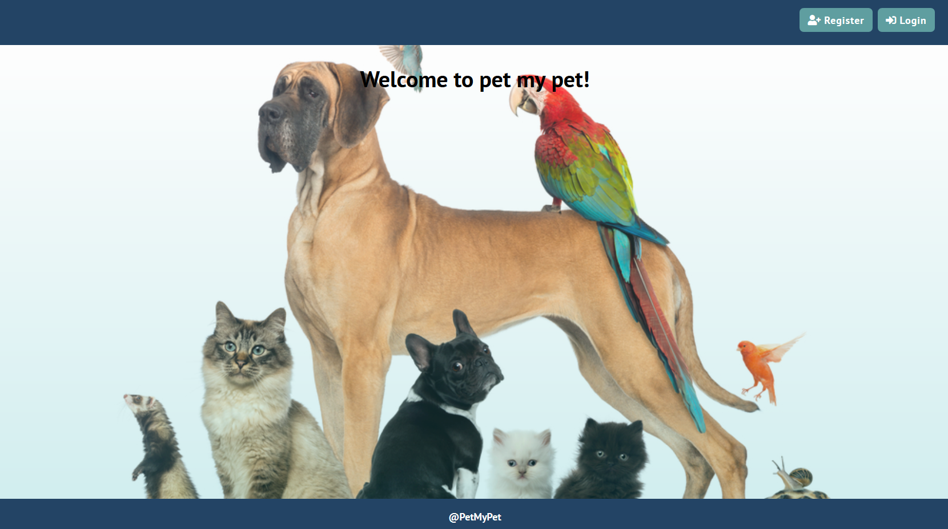

Register User (10 pts)
By given username and password the app should register a new user in the system.
- The fields should be non-empty. The username must be at least 3 symbols, and the password at least 6.
- After a successful registration, a notification message "User registration successful." should be displayed and the home page should be displayed again but with the right navbar.
- In case of error (eg. invalid username/password), an appropriate error message ("Username must be at least 3 symbols", "Password must be at least 6 symbols") should be displayed and the user should be able to try to register again.
- Keep the user session data in the browser’s session storage.
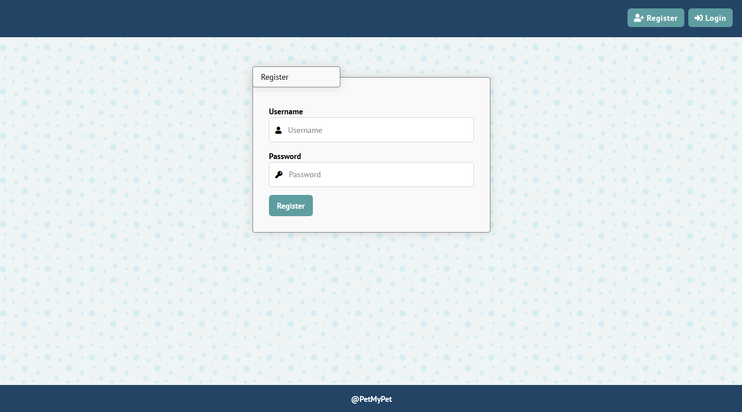

Login User (5 pts)
By given username and password the app should be able to login an existing user.
- The validations of the fields must be as in "Register"
- After a successful login, a notification message "Login successful." should be displayed and the user home screen should be displayed.
- In case of error, an appropriate error message should be displayed and the user should be able to fill the login form again.
- Keep the user session data in the browser’s session storage.
- Clear all input fields after successful login.
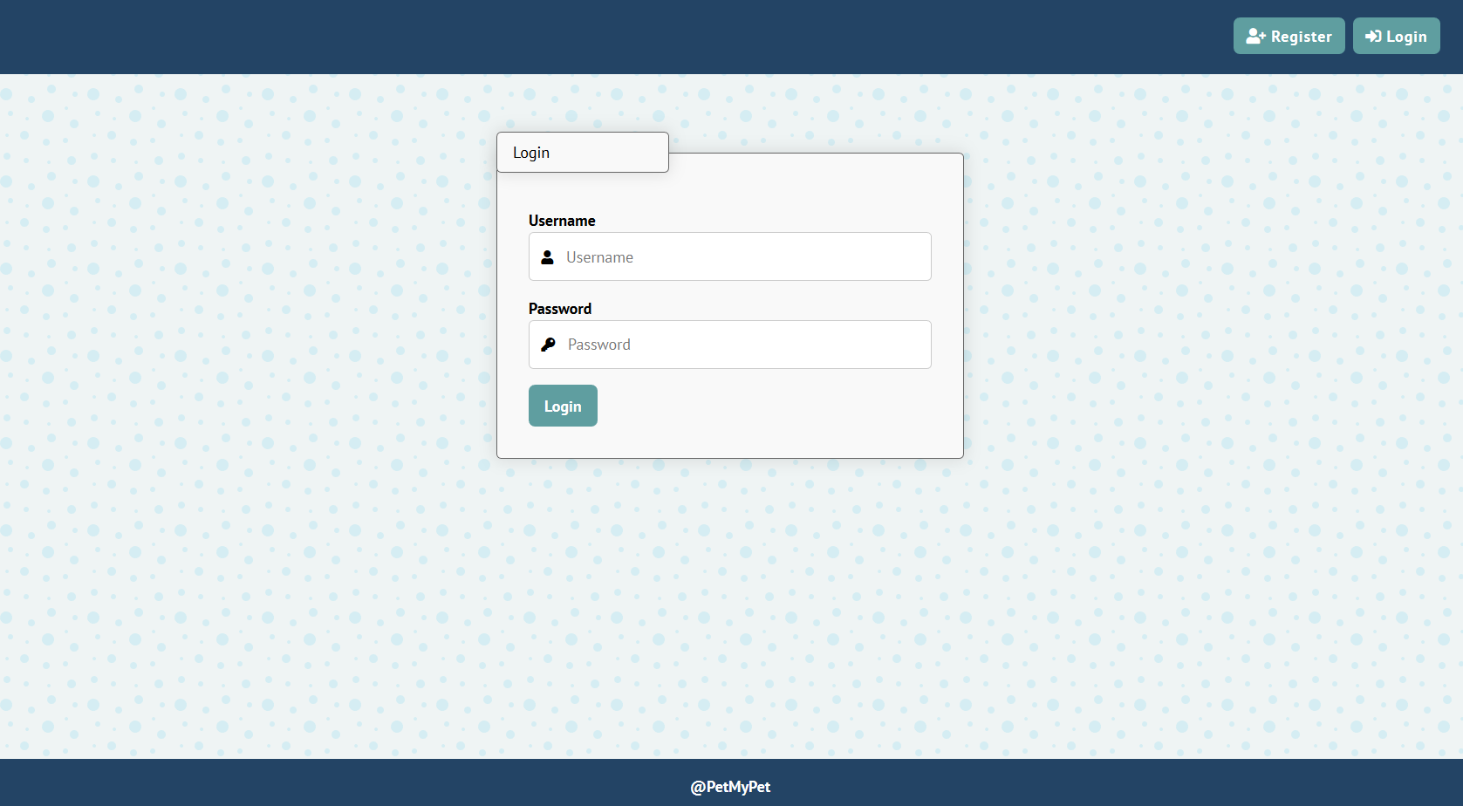

Logout (5 pts)
Successfully logged in user should be able to logout from the app.
- After a successful logout, a notification message "Logout successful." should be displayed.
- After successful logout, the anonymous screeen should be shown.
- The "logout" REST service at the back-end should be obligatory called at logout.
- All local information in the browser (user session data) about the current user should be deleted.

Logged In Dashboard (30 pts)

All Pets (15 pts)
Successfully logged users should be welcomed by the home screen. They should also be able to see the dashboard, which must have the following:
- The pets should be listed in the format as shown in the Web design (see the screenshot below).
- Only the pets that are not created by the current user should be listed!
- Each pet has name, image, description, category.
- When the details link is clicked, your app should redirect to the details section of the pet.
- When the pet link is clicked, the "pet counter" of the pet should be increased (it should start from 0)
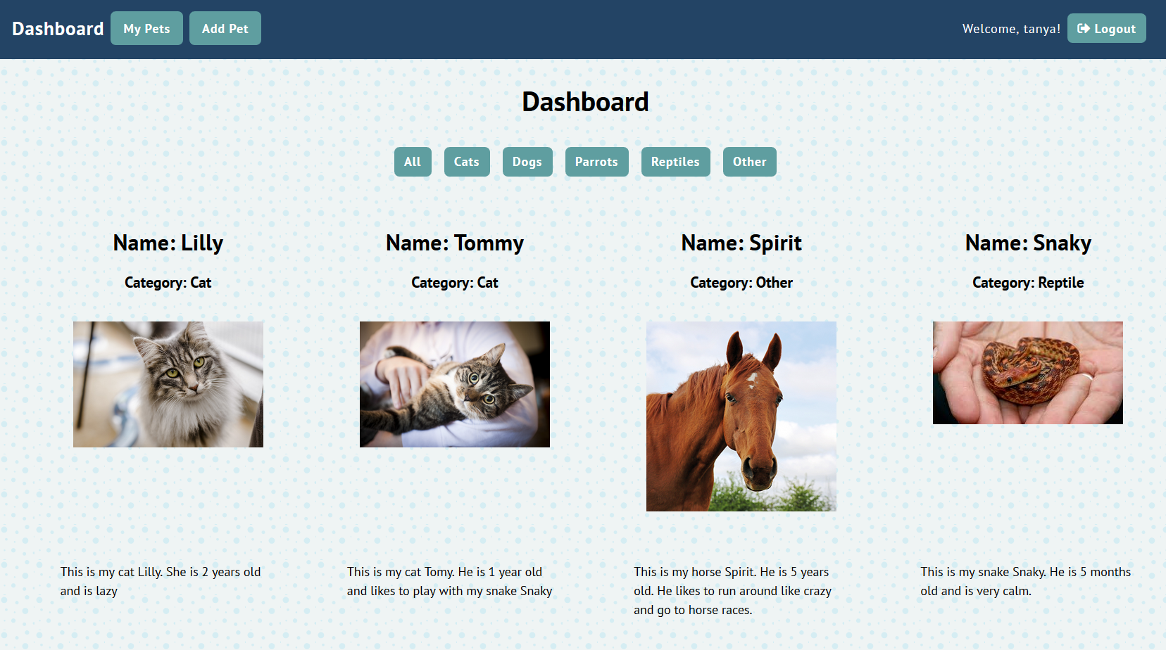

Categories (15 pts)
- When clicking on some of the categories, the pets should be filtered by the selected category and oredered by their "pet counter" in descending
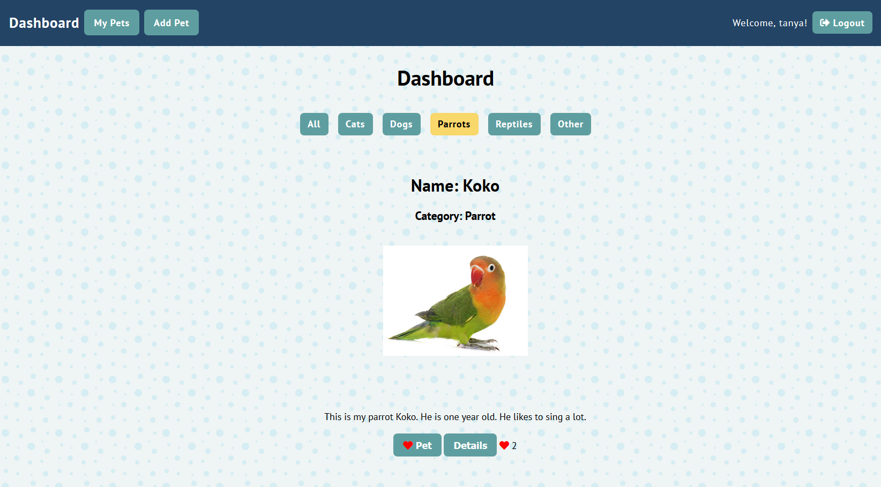

Add Pet Screen (10 pts)
Logged in users can add pets. Clicking the [Add Pet] link should open a form.
- After a successful pet creation, a notification message "Pet created." should be displayed and the home page should be shown.
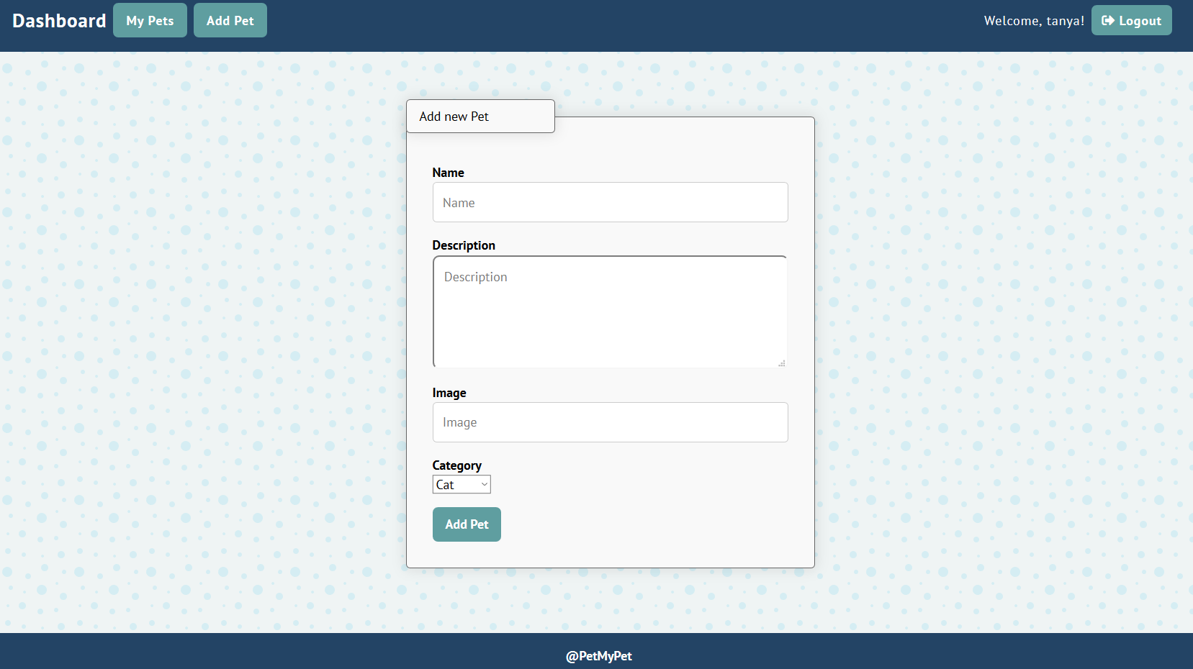

My Pets (10 pts)
Each user should be able to view his own pets by clicking [My Pets].
- The pets should be listed like in the dashboard section, except the "Pet" button is replaced with "Delete" button (users cannot pet their own pets) and the "Details" button is now "Edit" button. No ordering needed.
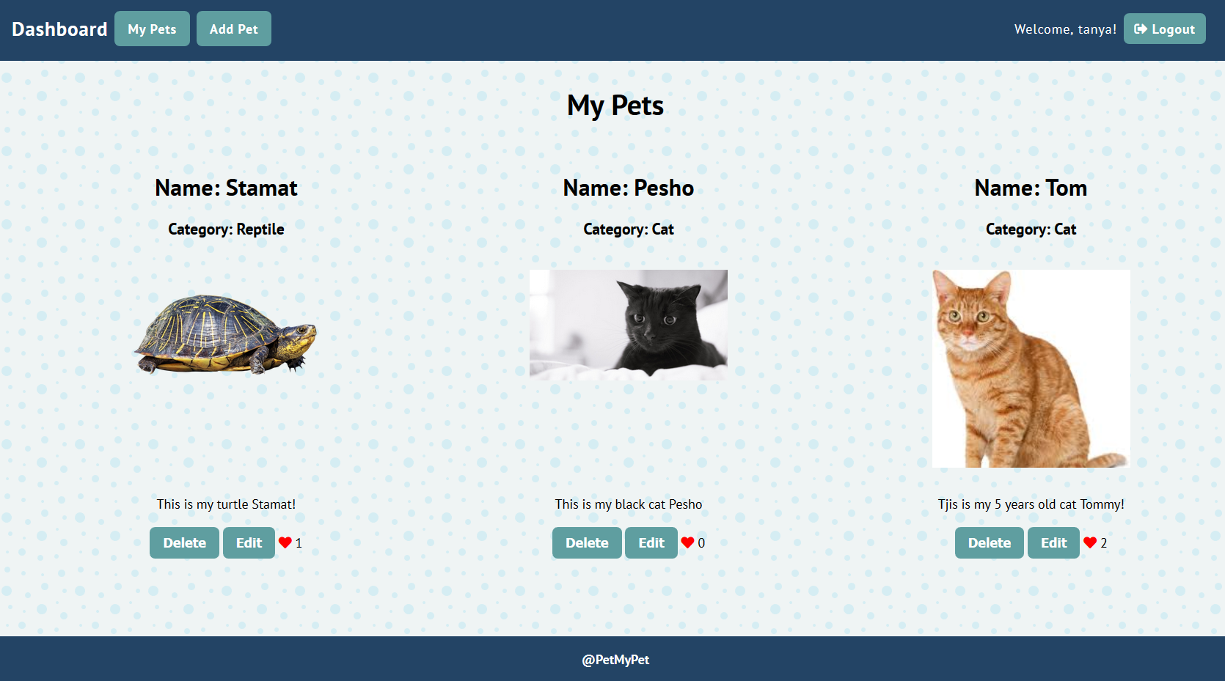

Edit/Details Pet Screen (5 pts)
Users should be able to edit their own pet's description. Clicking the [Edit] link on each pet should open a details page. Inside there should not be a "Pet" button and the description should be displayed in a text box. There should also be a "Save" button to save the changes.
- After a successful pet update, a notification message "Updated successfully!" should be displayed and the dashboard should be shown.
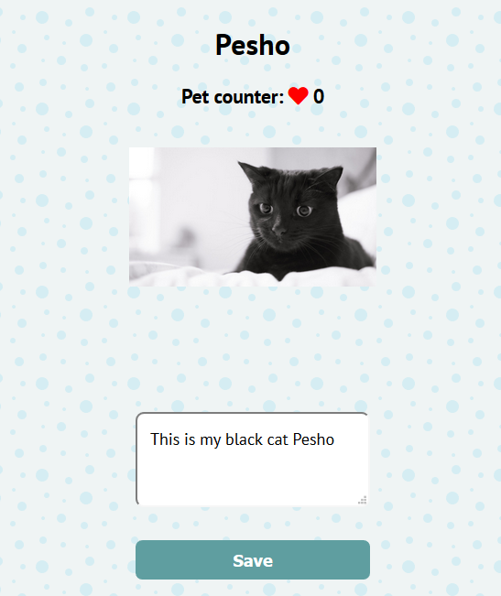
- Users should be able to see [Details] button on other pets and they should be able to "Pet" them, but not edit them:
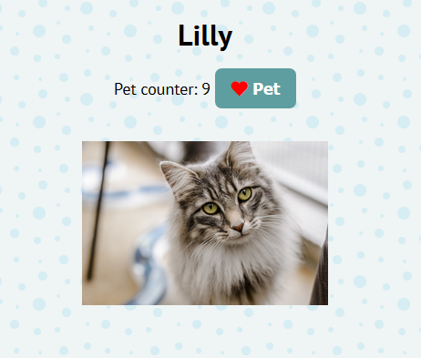

Pet a pet (5 pts)
Every user should be able to pet other pets, but not his own. By clicking on the [Pet] button, the counter of each pet increases.

Delete Pet (5 pts)
Owners should be able to delete their own pets by clicking the [Delete] button.
- When the button is clicked, display the following page:
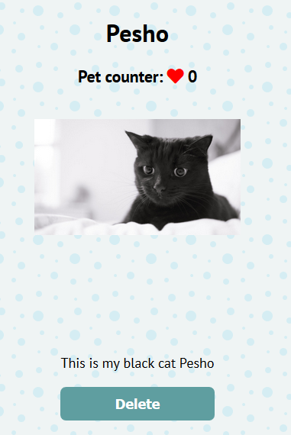
- When the button "Delete" is clicked, the pet should be deleted
- After successful pet delete a notification message "Pet removed successfully!" should be displayed and the home catalog should be shown.

Subtmitting Your Solution
Place in a ZIP file your project folder. Exclude the node_modules folder. Upload the archive to Judge.

